THE DRASCOMBE ASSOCIATION

2018 Strangford Rally

Friday 29th June – Sunday 1st July

Location
The event will be held at East Down Yacht Club, Moymore, Killyleagh, Co Down. EDYC is located on the Western shore of Strangford Lough opposite Island Taggart. It is approached along a concreted single‐track lane through a farm. The lane entrance is on the right, about 1.5 miles North of Killyleagh on the A22 road to Comber. We will mark the entrance to the lane with a Drascombe / EDYC sign.
There are some passing places and speed ramps on the lane, so caution, especially for cars towing boat trailers is recommended. There is a card-operated gate at the end of the lane, which we will have opened for visitors. EDYC does not own the lane but has a right of way over it. To maintain good relations with our neighbours please drive considerately in the lane and approaches to the clubhouse. There is a members’ caravan site at the club so when driving through the area please be aware that small children may be playing

Facilities at EDYC
Camping sites will be available on request. There are hot showers, washing and toilet facilities in the clubhouse. A limited number of caravan parking sites may be available. These are on grass pitches and do not have ‘hook-up’ services. Advance booking is essential, so let us know by email. There is a small charge for caravan & camping sites (no electrical hook up). Bar, tea coffee and snack facilities are available at the Holm Bar in the clubhouse. Access to the clubhouse is by security card at the main door. Arrangements will be made for rally participants’ access. The slipway can be used for launching and recovery at all states of the tide, unless it is exceptionally low. The pontoon is accessible at all points of the tide, and boats may be rafted on the pontoon, including sleep-aboards.

It is an EDYC requirement that children under 12 years of age, and all non-swimmers must wear personal buoyancy when using the pontoon and its approaches. It is a Drascombe Association requirement that all boat owners have a current insurance policy, at the required level of £3m in respect of third party liability claims with an authorized UK/EU insurer. Please refer to the DA Rally Booking Form. Help (and advice) will be at hand from John and David on Friday evening and Saturday morning for launching.

Sailing on Strangford
Strangford Lough is a shallow sea lough with an abundance of islands and wildlife. It is ideal for Drascombe sailing. The relevant chart in the Admiralty Leisure series is SC 2156. At low tide most of the area north of the EDYC slipway dries out. It is generally accessible from half tide. South of the slipway is navigable for Drascombes at all states of the tide but local knowledge suggests keeping to the centre channel. The South channel from EDYC to the open Lough is marked by two poles at the entrance. A third pole to the West marks rocks. In the Lough there are a number of tidal rocks and pladdies some of which, in the main sailing areas, are marked by poles.
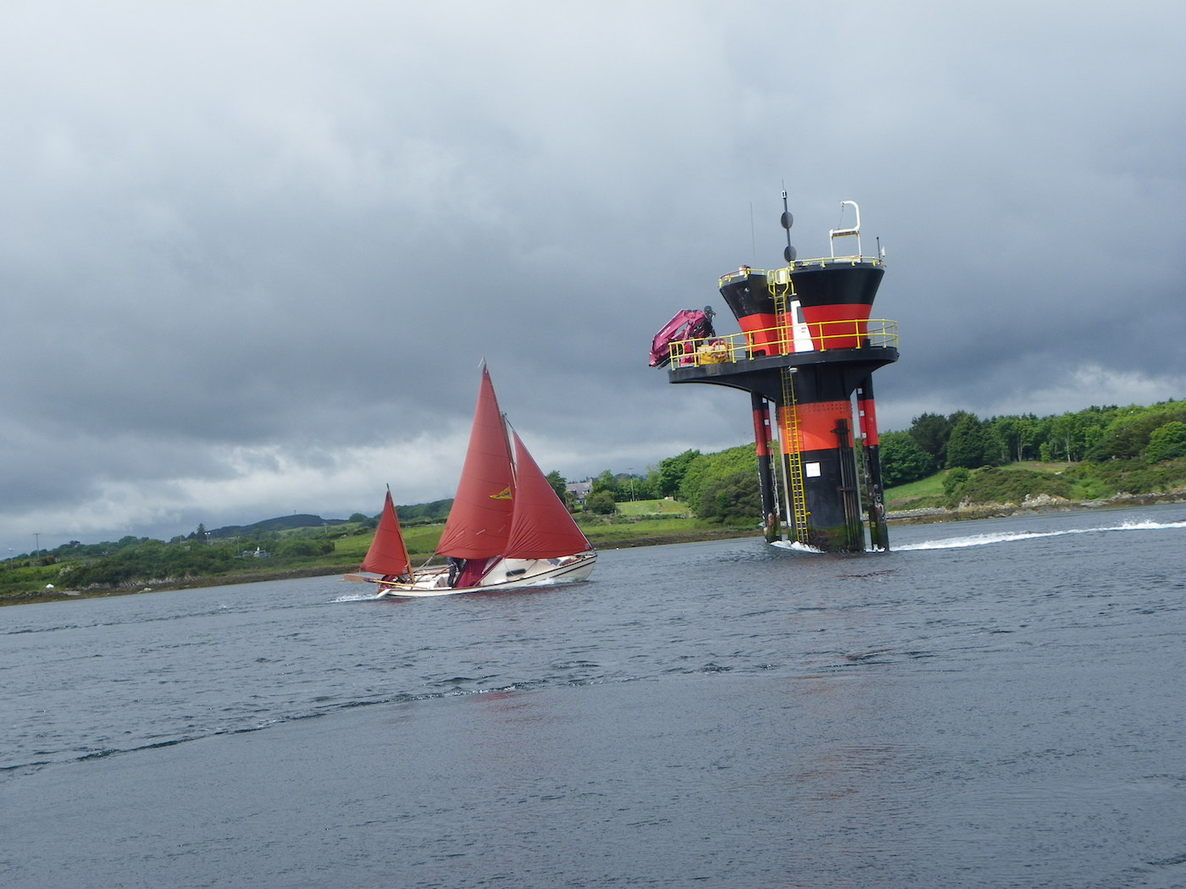
There is a very strong tidal flow, up to 8 knots, in the channel to the Irish Sea known as the Narrows. (This photo from the Narrows by John White was the winning entry in the DAN photo competition). If you do not wish to go with the tide it is best to navigate this area at slack water only. A car ferry operates between Portaferry and Strangford town.
Some islands are privately owned, the National Trust owns some, and others are reserved for wildlife. Wildlife reservations are important as our event is taking place during the main breeding season. The Islands Dunnyneill, Gibb’s, Salt, Green, The Launches, Ballyhenry, Horse, Taggart and Darragh belong to the National Trust and can be visited. We ask you to avoid the low NE part of Dunnyneill. Much of the Strangford Lough seabed is mud and requires a suitable anchor. Areas of the mud are very soft at low tide, and walking on it is inadvisable.

Tidal predictions for the weekend are as follows:

Friday 29th Jun
09.43 Low Tide 0.66 Meters
14.48 High Tide 3.42 Meters
21.51 Low Tide 0.81 Meters

Saturday 30th June
10.09 low Tide 0.68 Meters
15.24 High Tide Meters 3.38 Metres
22.16 Low Tide 0.84 Meters

Sunday 1st July
10.33 Low Tide 0.69 Meters
16.01 High Tide 3.36 Meters
22.42 Low Tide 0.84 Metres

Sailing Programme
The sailing programme will be dependent upon tides and wind direction each day.
Friday 29th June. Arrival, launching and informal sailing.

On Saturday and Sunday we intend to begin each morning with a briefing at approximately 10.00am on the Pontoon, when the plans for the day will be outlined. Options include sailing East to the opposite shore of the Lough, with the possibility of entering the pool at Ardkeen, or sailing North up the Lough and stopping at some suitable island for lunch. Sailing North towards White Rock or South past Killyleagh towards the Quoile Barrier are also options.

Social Programme
An informal welcome awaits in Holm Bar on Friday evening. The bar will be open, and there are restaurants and fast-food outlets in nearby Killyleagh.
Saturday evening there will be a mid-summer barbeque and entertainment in the clubhouse, joining the EDYC members.

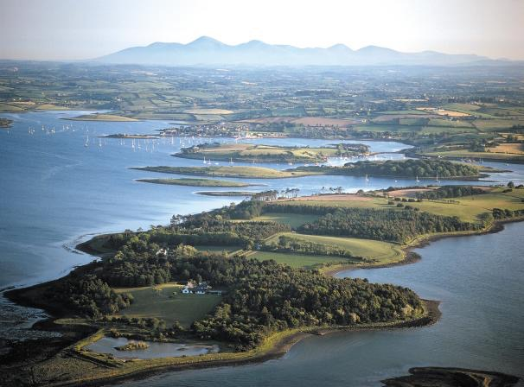
In true Drascombe spirit, the emphasis for this event is relaxed enjoyment. Please do not feel under any pressure to sail if you are not happy with the weather or itinerary. Crew without boats are welcome. We will fit you in. The decision to sail rests with individual skippers. There are lots of good restaurants and alternative activities locally. We will be happy to advise on these, particularly for non-sailing members of the family.

Contacts
John Stanage 07834466511
john.stanage646@gmail.com

David Bruce 07736547500
davidbruce@me.com

